**CHAPTER 1**

**OVERVIEW**

**1.1 INTRODUCTION**

This project entitled with Club’s Management System. This application developed using HTML and CSS as front end and backend is MYSQL.

With the advance in time and technology there is a need for faster dissemination of information. Many manual processes are being automated. CMS is one such web based application that keeps Students updated with what is happening in the College Clubs. The backend will be regularly updated by the Club administrator.

Club’s management system can make the work easier for Club administrator by providing well structured backend to update the server with current happenings and future updates of the Clubs to Student. The Fronted is also structured in such a way that each and every student gets it easy to use the UI.

**1.2 OBJECTIVES**

* To develop the well-designed database to store club’s information.
* Provides full functional report for the management of the club’s.
* The objective of this project is to provide a comprehensive approach towards the management of the club’s management.
* Provides the searching facilities based on various club details such as club- name, club-members.
* It tracks all the information of club, like club-activities, club-meetings.

**1.3 EXISTING SYSTEM**

In any institute or an organization, we can find only single club management system, for example, sport management system etc. This is the existing system in which we can’t find all the club details and in some of the systems we have records preserved in the form of hardcopy. Sometimes there are chances of losing these records which may result in some kind of problems.

**1.3.1 EXISTING SYSTEM DISADVANTAGES**

* Not secure.
* The system is not able to provide a list of all members, the time they joined, the events they are conducting.
* Paper waste.
* The system is not providing easy access to member details.

**1.4 PROPOSED SYSTEM**

The proposed system can effectively maintain the record of members with more security. The executive or the admin can effectively store and retrieve the member information. The proposed system has many attributes like club details, event details and maintaining meeting record in any institution. The proposed system allows the admin or executive of an institution to effectively retrieve the member details.

**1.4.1 PROPOSED SYSTEM ADVANTAGES**

* Provides security.
* Easy retrieval of information
* Better look and feel
* Easy to manage the entire system
* Maintains details of members like the club joined, when they joined etc.

**1.5 SCOPE OF THE PROJECT**

One of the most important steps in the process of development of the system is to have a well defined scope of the system. The scope of the system sets down the boundaries and areas covered by the system.

* We can add, update and delete all the new as well as existing records.
* The CMS is mainly designed for club details and to maintain the club members.
* The system is user friendly and maintenance of the information is easy.
* To minimize the time.
* To data entry and make data access possible.

**1.5.1. ADVANTAGES**

* Provides computerized system for maintaining records.
* More efficient and reliable.
* Less time consuming and easy to use.
* Avoids data inconsistency and redundancy.

**CHAPTER 2**

**SYSTEM REQUIREMENT SPECIFICATION**

**2.1 FUNCTIONAL REQUIREMENTS**

Functional requirements are related to the system behavior only for the certain inputs that should satisfy. They are linked to the exceptions from the intended software. They are also called as product features.

**2.2 NON FUNCTIONAL REQUIREMENTS**

Non functional requirements are those which are not transported by the system but they are the quality of the system.

* Authentication: Application must provide security. Only authenticated users can login and get the member details.
* Performance: Should provide better performance by minimizing time.
* Application should work without any interruption.
* Application should be available at any time and when required.

**2.3 SYSTEM REQUIREMENTS**

System requirement are expressed in software requirement document. It is the official statement for what is required for the system developers. Requirement document includes the requirement definitions and the requirement specifications.

The software requirement document is not designed document. It should set out what the system should do without specifying how it should be done.

* Storing the information of the member in the customized database.
* Accessing information of the member.
* Making queries for adding and searching member details.

# 2.3.1. HARDWARE REQUIREMENTS

* Processor : 2GHz Intel core processor
* RAM : 4GB or more
* Hard-Disc : 100GB or more

**2.3.2. SOFTWARE REQUIREMENTS**

* Operating system : Linux(Ubuntu)/Windows
* Language : HTML,CSS,PHP
* Database : MySQL
* Tools : Sublime Text, Atom, Bracket
* Server : Apache2

**CHAPTER 3**

**SYSTEM DESIGN**

**3.1. SYSTEM DESIGN DIAGRAM**

De-serialize accessed data and update UI

 WEB SERVER

Internet

GET/POST Request

Web

Data in form of Models

DATABASE

**Fig 1. System Design diagram**

The member data is stored in the database and is connected to the server. The server sends data in the form of HTTP Response when request is sent to it.

**3.2. E R DIAGRAM**

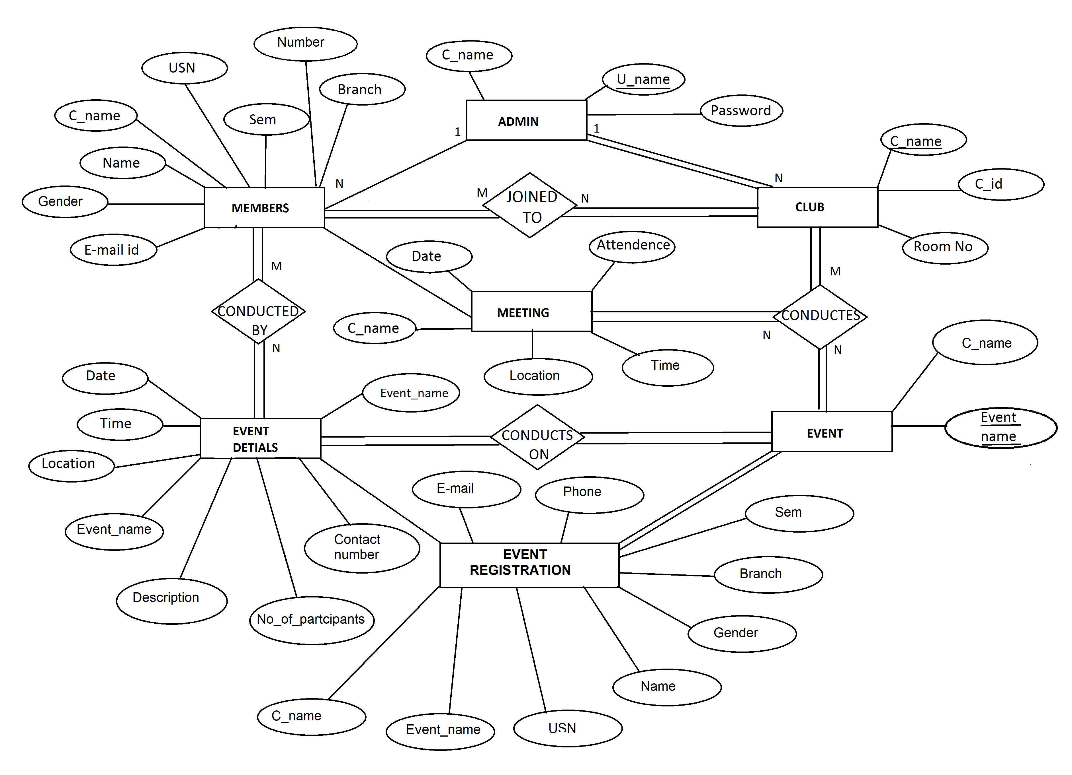

**Fig 2. ER Diagram**

ER diagram is a visual representation of data that describes how data are related to each other. ER diagrams are essential to modelling anything from simple to complex database .There are 6 entities defined namely Members, Admin, Club, Meeting, Event, Event Details. Each entity is having relation among one another as show in the Fig 2. The attributes are represented in circles.

**3.3. DATABASE SCHEMA**

# CLUB

|  |  |  |
| --- | --- | --- |
| C_name | C_id | Room_no |

## ADMIN

|  |  |  |
| --- | --- | --- |
| C_name | U_name | Password |

**MEMBERS**

|  |  |  |  |  |  |  |
| --- | --- | --- | --- | --- | --- | --- |
| C_name | Name | USN | Sem | Branch | Gender | E-mail_id |
| number |  |  |  |  |  |  |

**EVENT**

|  |  |
| --- | --- |
| C_name | Event_name |

**EVENT DETAILS**

|  |  |  |  |  |  |  |
| --- | --- | --- | --- | --- | --- | --- |
| Event_name | Date | Time | Location | Description | Contact | Number |

**EVENT REGISTRATION**

|  |  |  |  |  |  |  |
| --- | --- | --- | --- | --- | --- | --- |
| Event name | name | USN | Gender | Branch | Sem | C_name |
| e-mail | phone |  |  |  |  |  |

**MEETING**

|  |  |  |  |  |
| --- | --- | --- | --- | --- |
| C_name | Date | Attendance | Time | Location |

**Fig 3. Database schema**

It contains a descriptive detail of the database, which can be depicted by means of schema diagrams. The database schema of the system is structure described in formal language. The primary keys are underlined as shown in figure. There are six entities with multiple attributes in it.

**CHAPTER 4**

**IMPLEMENTATION**

The process of putting our plan into execution is said to be as implementation. This implementation process can vary from organisation to another organisation .It is a process that convert strategies and plans into actions to reach required goal.

**4.1. TOOLS USED**

**4.1.1 HTML**

Web browsers receive HTML documents from a web server or local storage and render the documents into multimedia web pages.HTML describes the structure of a web page semantically and originally included cues for the appearance of the document.HTML elements are the building blocks of HTML pages.

**4.1.2 CSS**

CSS is designed to enable the separation of presentation and content, including layout, colors and fonts. This separation can improve content accessibility, provide more flexibility and control in the specification of presentation characteristics, and enable multiple web pages to share formatting by specifying the relevant CSS in a separate css file.

**4.1.3 MYSQL**

It is an open source relational database management system. The MySQL development project has made its source code available under the terms of the GNU General Public License, as well as under the variety of proprietary agreements. MySQL was owned and sponsored by a single for profit firm, the Swedish company MySQL AB, now owned by Oracle Corporation.

**4.1.3.1 TRIGGERS**

  A trigger is a stored procedure in database which automatically invokes whenever a special event in the database occurs. For example, a trigger can be invoked when a row is inserted into a specified table or when certain table columns are being updated.

**4.1.3.2 STORED PROCEDURES**

A stored procedure is a group of SQL statements that has been created and stored in the database. A stored procedure will accept input parameters so that a single procedure can be used over the network by several clients using different input data.

**4.1.4 PHP**

PHP is a widely-used open source general-purpose scripting language that is especially suited for web development and can be embedded into HTML.

# 4.2MODULES

**Club’s Admin Login**

Club admin or higher authority can login with his username and password. Admin can make the changes of the club description.

# Club’s Details

The description about the club entered by the admin is storied and displayed in the dashboard.

# Club’s Activities

The activities conducted by the club’s and the description about that events are describes here.

# Club’s Meeting

The decision is taken in the meeting and the topics are discussed in the meeting and the detailed about the meeting is placed here.

**CHAPTER 5**

**IMPLEMENTATION OF RESULTS**

**5.1 SNAPSHOTS**



**Fig 4: Initial page of the system.**

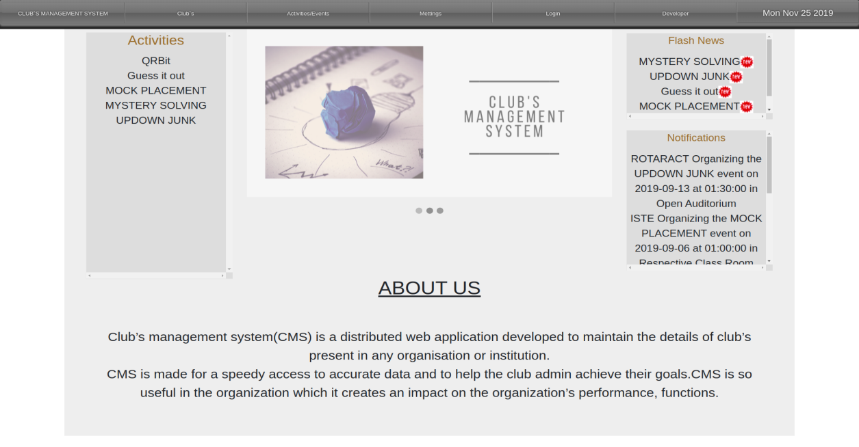

**Fig 5: Main page of the system.**

**CLUB’S MAIN PAGES**



**Fig 6: ISTE page**



**Fig 7:Rotaract club page**

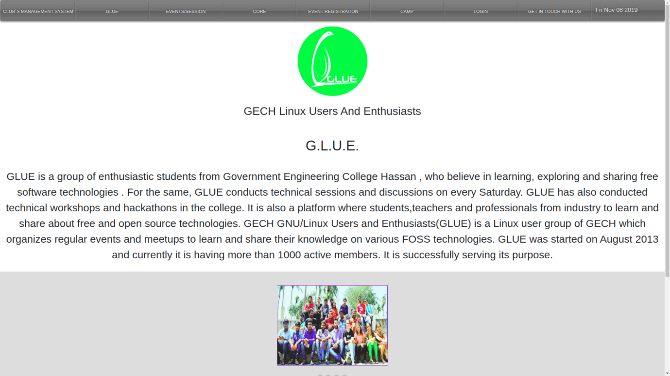

**Fig 8:GLUE page**



**Fig 9:GEON page**

**EVENTS/ACTIVITIES PAGE**

The work of this page is to display the details of the events/activities such as club name, event name, date, time, location etc. This page also offers an operation which is sorting. Sorting is done on the basis of club name.

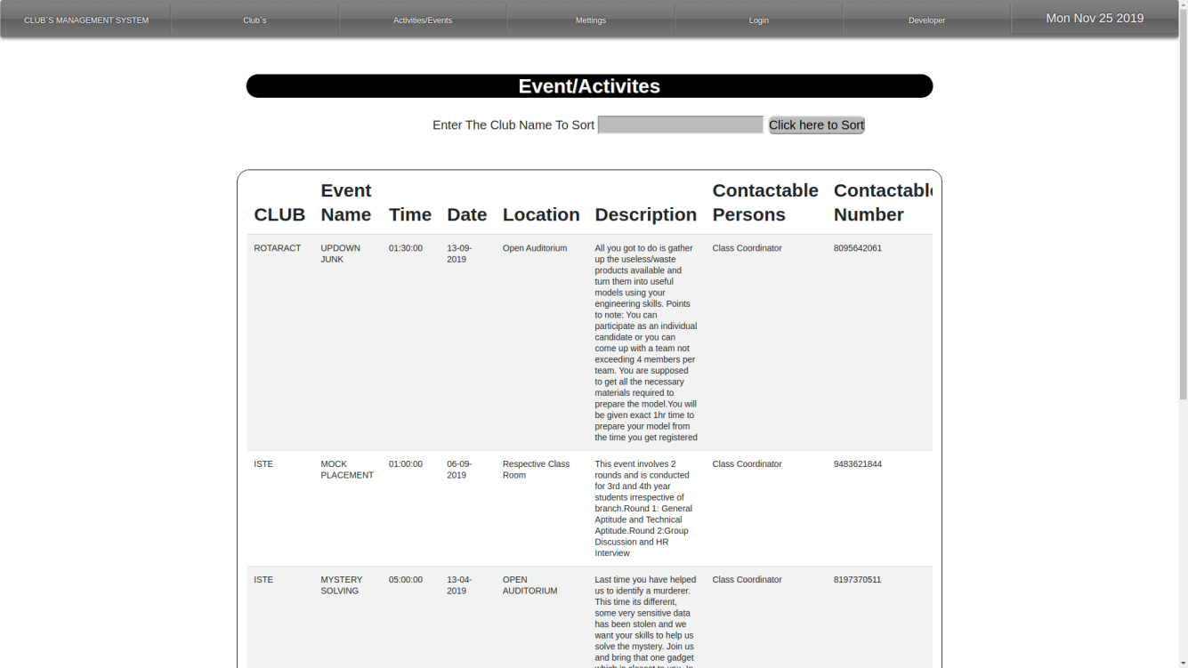

**Fig 10: Events/Activities page**

**MEETINGS PAGE**

The work of this page is to display the details of the meeting such as club name, date, time, location. This page also offers an operation which is sorting. Sorting is done on the basis of club name.

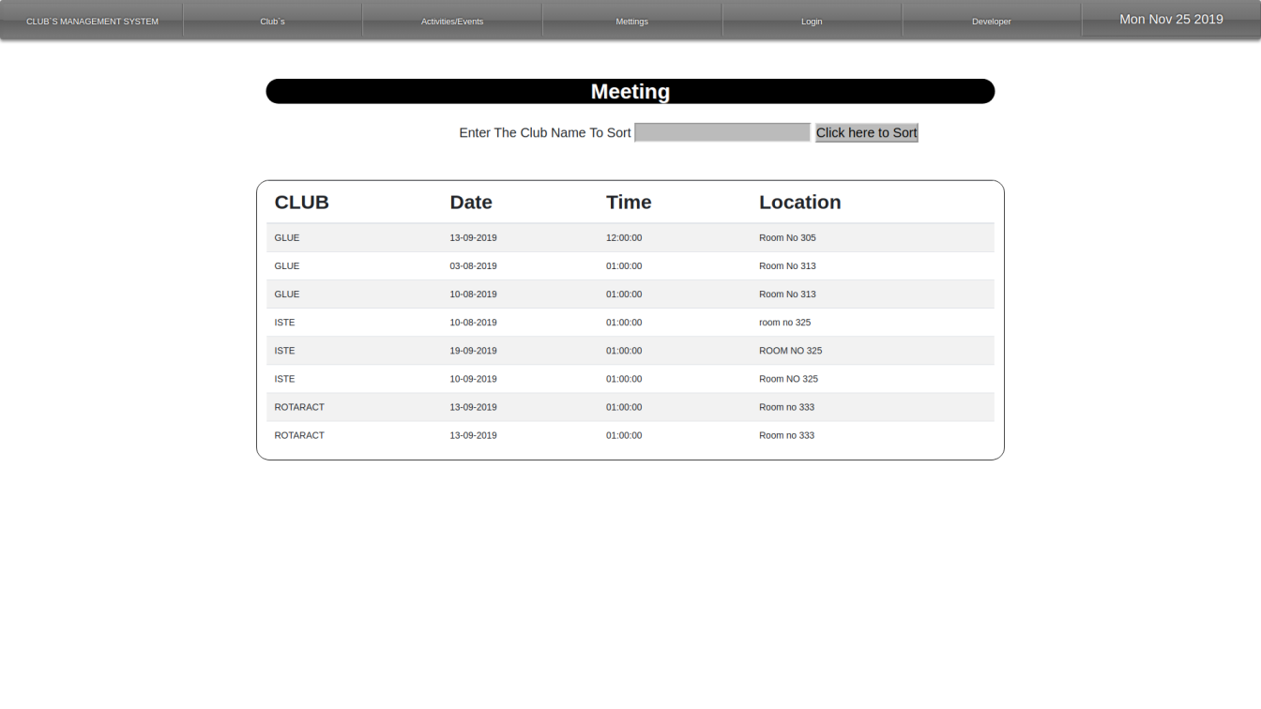

**Fig 11: Meetings page**

**MEMBER REGISTRATION FORM**

It contains the basic details which the member has to fill to join any club such as club name, name, USN, Semester, branch, gender, e-mail, phone number. Once the fields are filled and submitted ,the member is regsitered and a message is thrown saying “REGISTRATION SUCCESSFUL!!”

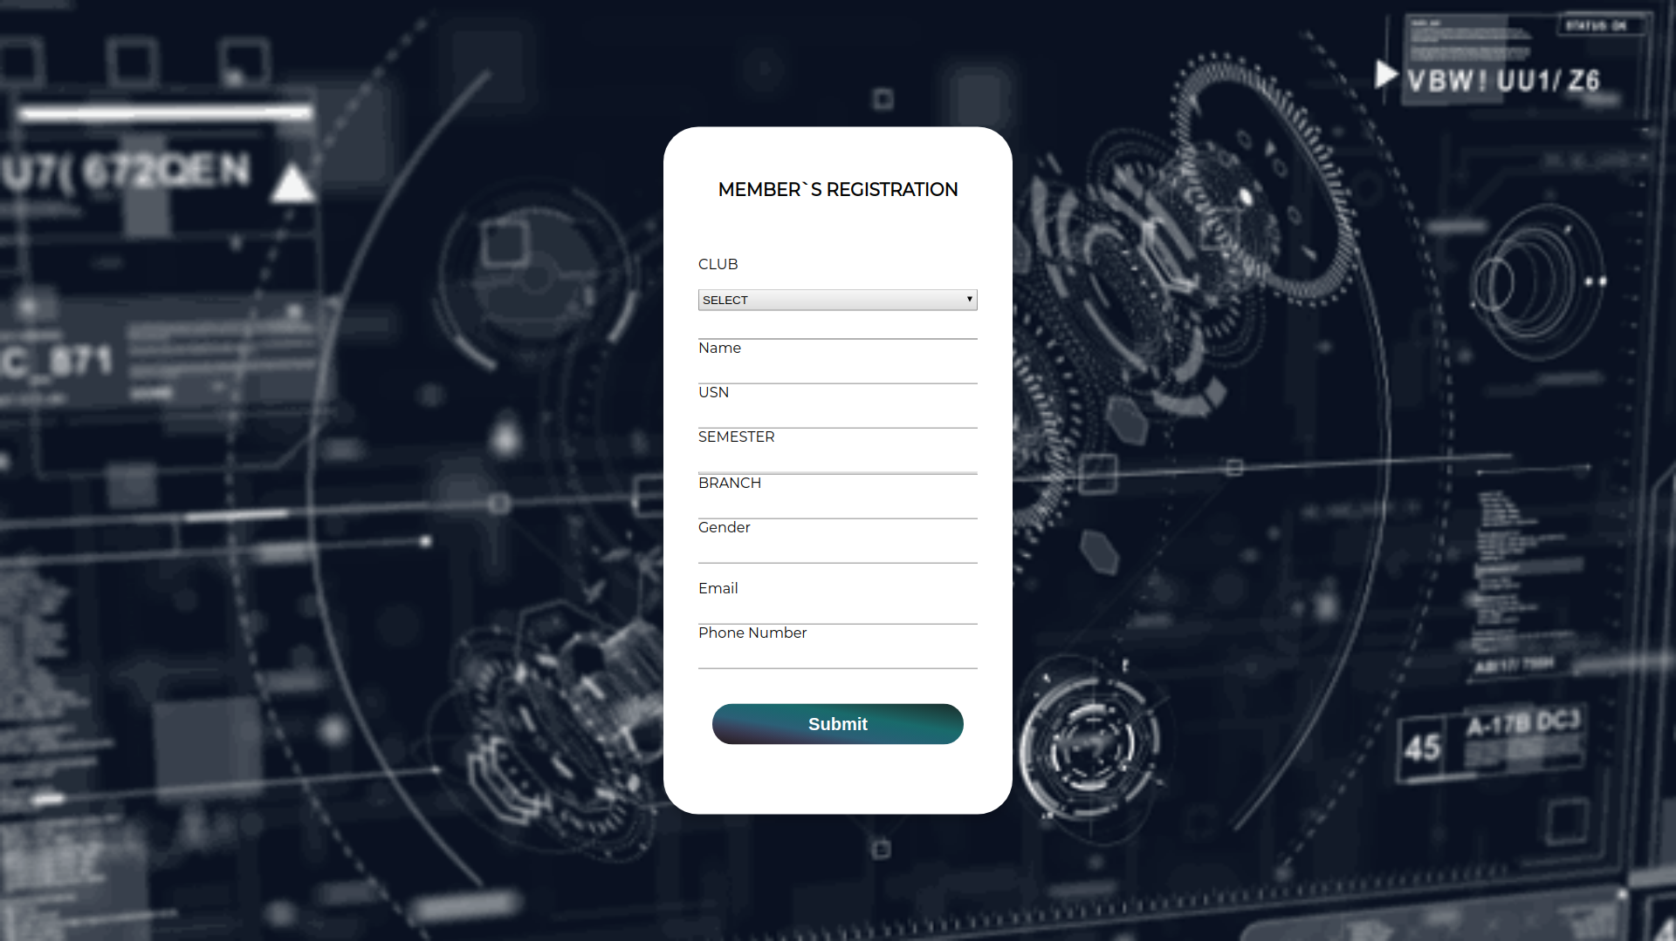

**Fig 12: Member registration form**

**EVENT REGISTRATION FORM**

This form allows the participants to get registered for an event by filling their details. These details are stored in database and can be accessed by the admin.

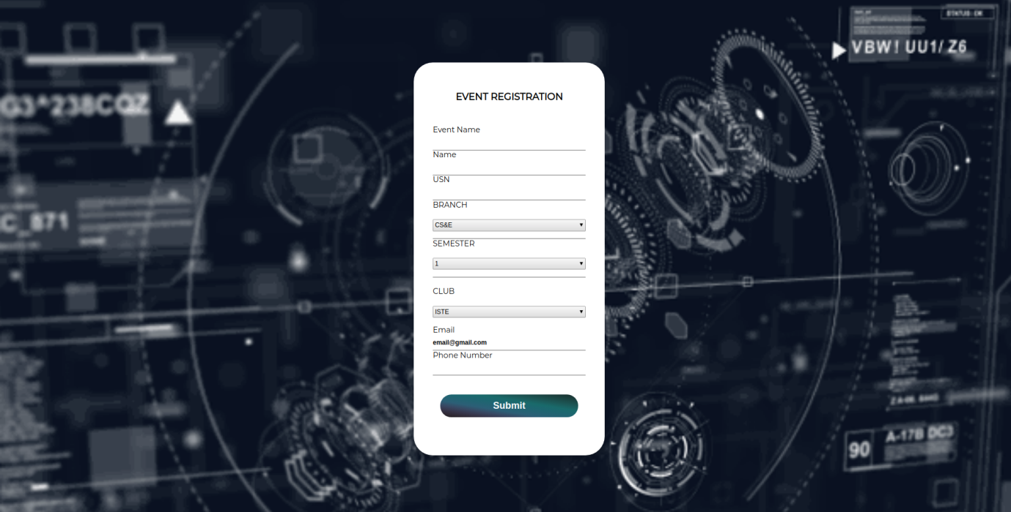

**Fig 13: Event registration form**

**ADMIN LOGIN FORM**

The job of login form is to take the information such as username, password and club name. When an admin enters correct login information it redirects to main page otherwise it gives error message.

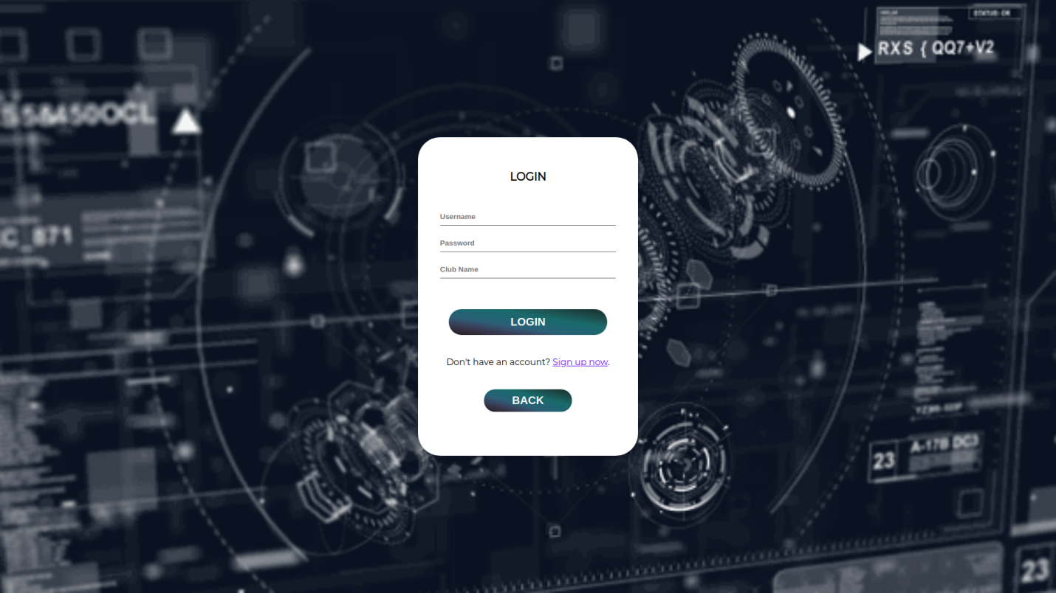

**Fig 14: Admin login form**

**PRIVILEGES GIVEN TO AN ADMIN**

There are some special privileges given to the admin. They are accessing member details , meeting commencement form and to create any event.

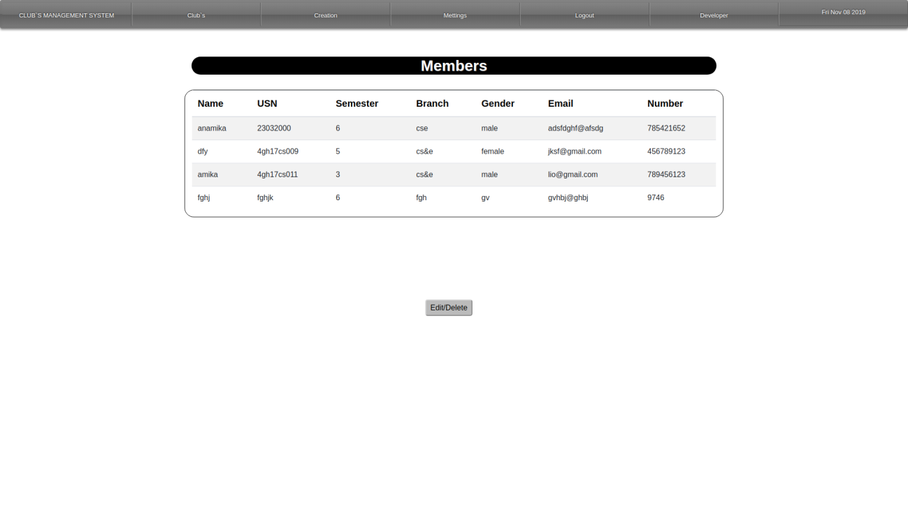

**Fig 15:Page consisting of table of member details**

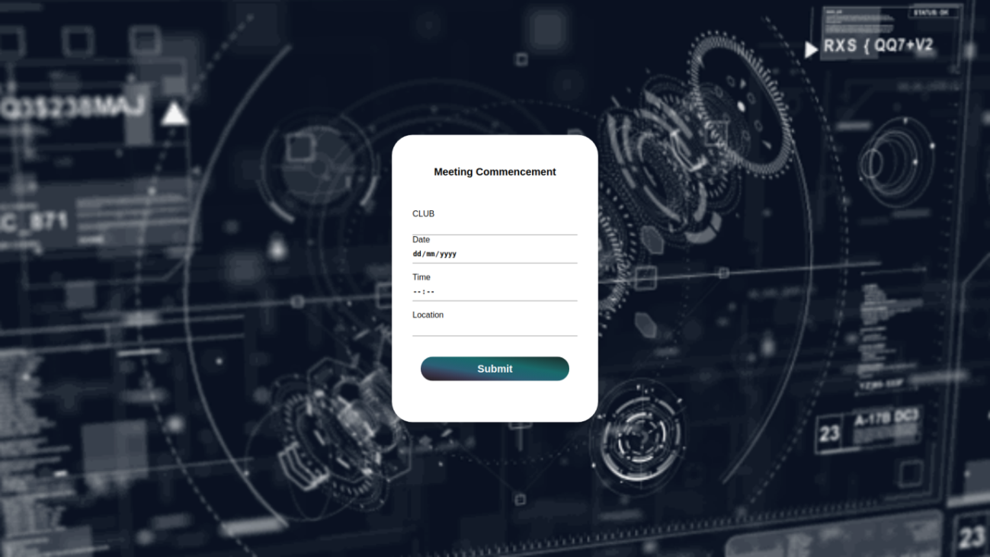

**Fig 16:Meeting commencement form**

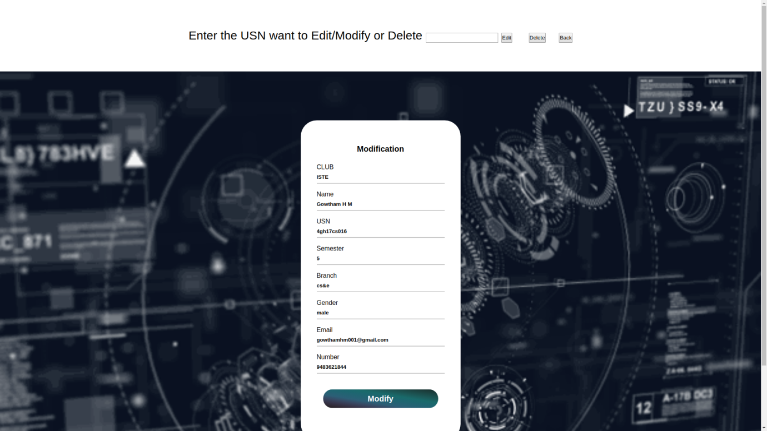

**Fig 17: Member modification form**

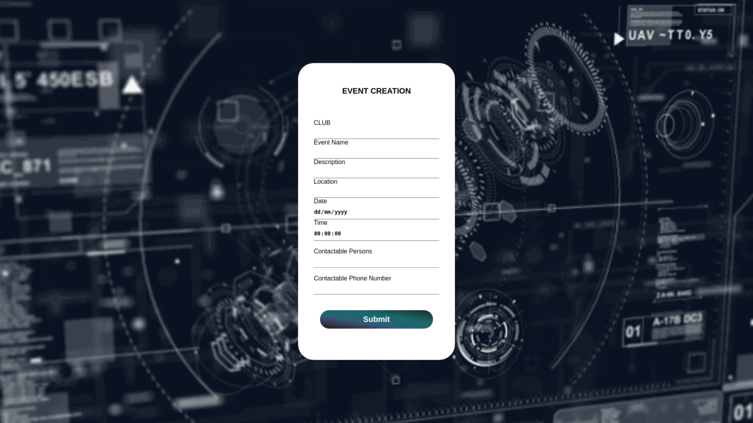

**Fig 18: Event creation form**

**EVENT REGISTRATION DETAILS DOWNLOAD PAGE**

The admin can download the registered participants list for a particular event into a xscl/cvs form. First page will be give the all the participants list who are registered to all the event, By giving the event name in a input field can sort the list of particular event participants list. By clicking the export as csv admin can download the csv file containing the participants list.

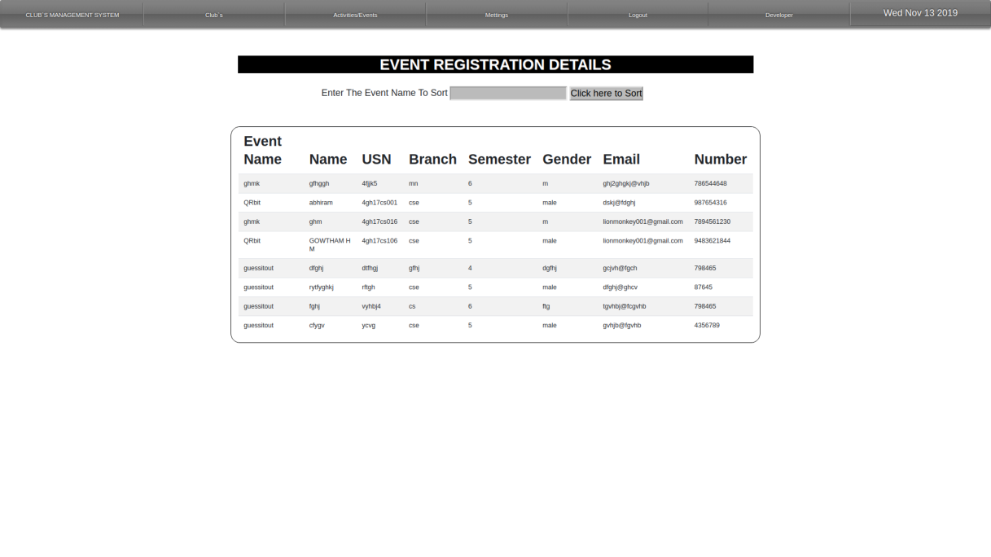

**Fig 19:Details Of Registered Participents**

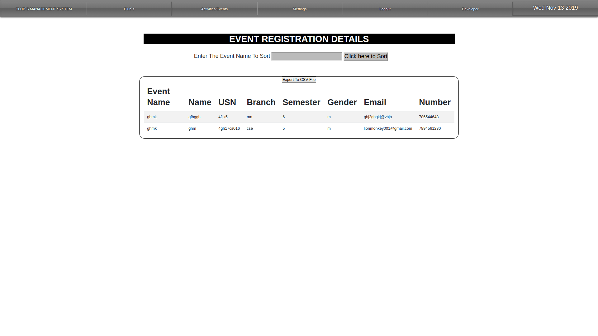

**Fig 20: Details Of Registered Participents Of Particular Event**

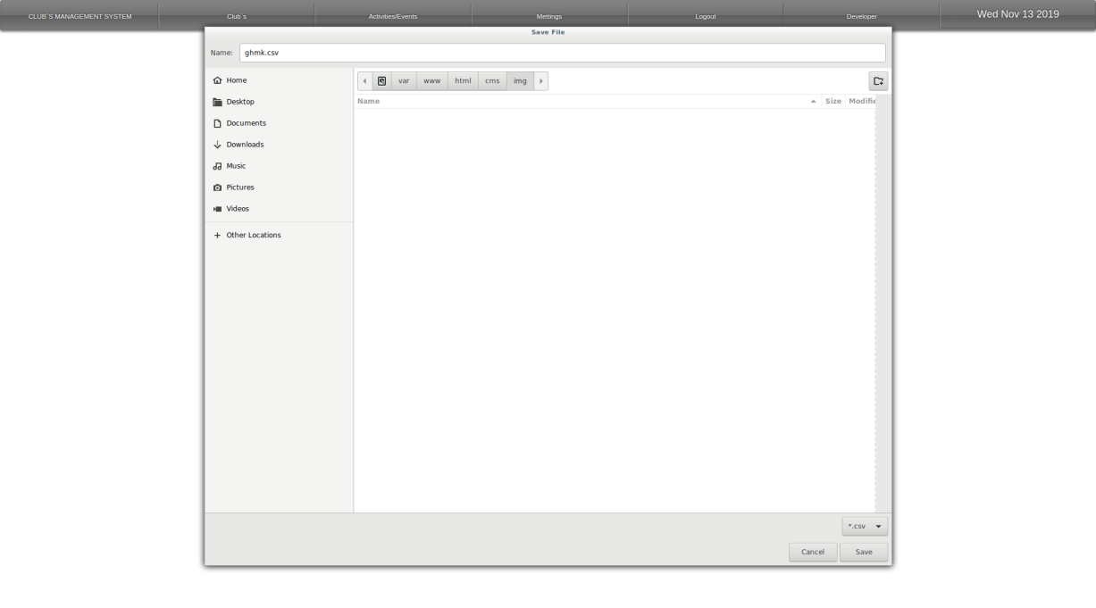

**Fig 21:Download Page Of The Participents List**